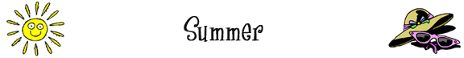
Summer
Summer is the ___________ of _____________ days and hot _____________. In summer, people try to escape the _____________ by turning on their __________________ and _____________, or going to the ______________.

Summer Food
One way to ______________ off is to eat something cold such as an ________________. Another favorite summer food is _________________, which is big, green, and ______________. And, of course, many people enjoy a cool glass of ________________ with a few _________________ to keep it cold.

Summer Clothing
In the heat of the summer sun, it is important to dress properly. It is a good idea to wear a ____________ on your head and ________________ to protect your eyes. If you want to _____________ cool, you can wear ________________ instead of pants and put _______________ on your feet.

Summer Vacation
In many countries, kids get a _________________ from school during the summer months. This is a good time to go ______________, swimming, _____________, or ________________.
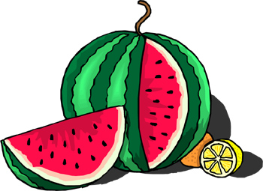 | Summer Animals  Summer is a good time for animals. There are lots of ________________ to eat on bushes. As well, many ______________ are about, making tasty treats for birds and spiders. Some of these insects such as _________________ look pretty in the garden. Unfortunately, others such as ________________ make a tasty treat out of people.

