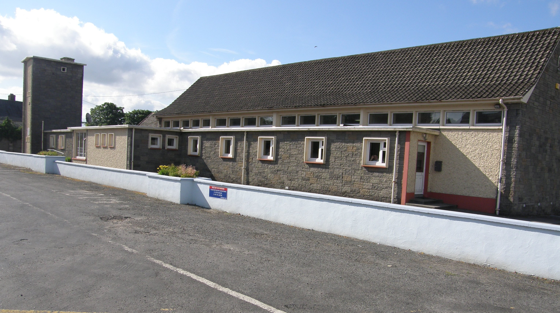

New Inn, Cashel,
Co.Tipperary.

Phone/Fax 052 7462122

www.newinngirlsschool.ie

Mission Statement

Scoil Mhuire Gan Smál, New Inn is a Catholic Christian School under the patronage of the Cashel & Emly Archdiocese. It was formerly under the trusteeship of the Sisters of Mercy and we still maintain the Mercy ethos. We foster a holistic approach to the development and education of our pupils. This school is committed to promoting a caring, happy and creative attitude in the children and staff and towards the environment with particular attention to those at risk.

Aims

Catholic
- To co-operate with parents in the Catholic upbringing of their children.
- To encourage children to become responsible Catholic adults.
- To participate in prayer and the sacraments.

Holistic
- To follow the national curriculum.
- To expose children to many different creative activities: e.g. music, dance, drama, art, etc.
- To develop social communication and organised skills.
- To build on children’s initiative in areas of responsibility and decision making.

Caring
- To foster good interpersonal relationships between all in the school: pupils, teachers, parents and non-teaching staff.
- To encourage children to be aware of the needs of others.

At Risk
- To try ensure that those at risk – educationally, medically, physically, nutritionally, emotionally and socially – are adequately cared for.

General Details

- Name of School – Mhuire Gan Smál
- Address – New Inn, Cashel, Co. Tipperary.
- Telephone Number/Fax – (052) 7462122
- Email: newinn.ias@eircom.net
- Web Address: www.newinngirlsschool.ie
- Denomination – Catholic
- Chairperson of School – Fr. Michael Kennedy P.P.

- 5 class teachers including Principal Teacher
- Learning Support Teacher
- Visiting Resource Teacher

- Classes taught: Junior Infants – 6th Class
- Mixed classes until 1st class, after which it is girls only.
- School opening time: 9-30 a.m.
- School closing time: 2-10 p.m. for infants
3-10 p.m. 1st class on

The Board of Management will only take responsibility for children during school hours and 10 minutes before opening time and 10 minutes after closing time. At all other times children are the responsibility of their parents.

Members of the Board of Management.

Chairperson: Fr. Michael Kennedy P.P
Principal: Fiona Ryan
Bishop’s Nominee: Mary O’ Connor
Teacher’s Rep: Teresa Harrington
Parent’s Rep: Paul Perry
Parent’s Rep: Deirdre O’ Connor
Community Rep: Philly Fahey
Community Rep: Michael (Taylor) Ryan

Parents’ Council

The Parents’ Council is a voluntary group of parents that:
- assists the school principal and teachers with extra curricular activities, such as the Annual School Concert and the Sports Day.
- They represent the views of parents and provide a forum for consultation with the Principal on relevant issues.
- They help the school /B.O.M financially when suitable opportunities arise.
- Organise a book sale of second –hand school books in June if there is sufficient interest
The Parents’ Council holds it’s AGM every autumn and all parents are invited to attend. The current officers are:

Jayne McConnon Chairperson 086 3926989

Michele Nugent Secretary 086 8565358
Catherine O’ Brien Treasurer 086 3047692

Teaching Staff

Junior Infants: Ms. Kinane

Seniors : Mrs. Harrington (Dep. Principal)

1st : Mrs. McMillan

2nd,3rd & 4th: Ms. Bourke

5th & 6th: Mrs. Ryan (Principal)

Learning Support: Mrs. Catherine O’Dwyer (shared with
Rosegreen N.S)

Resource : Mrs. Audrey Ryan (shared with John Baptist, Girls N.S. Cashel)

The above are the current class divisions but these may vary from year to year depending on our numbers. Enrolment for new entrants takes place in early spring and when we have a reasonable idea of our proposed enrolment for the following September it will be decided what classes will be split. Any split class will have to have a gender balance. It has been decided by the Board of Management that the divide will be made at random on a lottery basis. This draw will take place at the summer staff meeting in the presence of members of the Board.

School Hours
Office Hours
9.30am -3.30pm – Tues, Wed, & Thurs

9.30am – 12.00 - Fri
Opening Time 9.30a.m.
Closing Time 3.10p.m.
Closing for infants 2.10p.m.

Break Time: 10.50 a.m.- 11.00p.m.
Lunch Time: 12.30p.m.- 1.00p.m.

School uniform

Girls: Navy pinafore/skirt, white blouse, red jumper with school crest to be ordered through the school & red tie. School jackets with crest optional.

Boys: Navy trousers, blue shirt, navy v-neck jumper with school crest to be ordered through the school & navy tie. School jackets with crest optional.

P.E Plain navy track suit and white polo shirt and
runners.

Uniforms are available to purchase in Uniform World, Ard na Gaoithe Business Park, Cashel Rd., Clonmel, Co. Tipperary.

Please ensure all items of clothing are marked with your
child’s name. Younger children should attach a keyring or some identifiable object to their school jackets (Zip/Pocket)

P.E.
Children wear their P.E. clothes on dancing and P.E days and 1st to 6th class also wear P.E. gear on camógie days.

Ms. Kinane: Dancing on Wed., P.E. on Thursday

Mrs. Harrington: Dancing on Wed, P.E. on Thursday

Mrs. McMillan: Dancing on Wed, P.E./Camógie on Thursday

Ms. Bourke : Dancing on Wednesday, P.E./Camógie on Thurs.

Mrs. Ryan: Dancing & P.E. Wednesday, Camógie on Thurs

School Rules

- Children are expected to behave in a mannerly fashion and to be respectful towards their teachers and each other.
- Children are expected to be punctual.
- Chewing gum or mobile phones are not permitted in school.
- A note is required (By Law) to explain all absences.
- Children are to wear their proper school uniform or proper P.E. uniform in school.
- Children are expected to be clean and tidy and in the interest of reducing the incidence of head lice, those with long hair should have it tied back.

Behaviour/Code of Discipline

It is our aim to ensure that the individuality of each child is
accommodated, while acknowledging the right of each child to
education in a relatively disruption free environment. Every
effort will be made by all members of staff to adopt a positive
approach to the question of behaviour in school. The emphasis is
on rewards rather than sanctions in the belief that this will, in
the long run, give the best results. The school recognises the
variety of differences that exist between children and the need
to tolerate these differences and so the rules are being kept to
a minimum. Each class teacher has the responsibility for the
maintenance of discipline within the classroom. A pupil should be
referred to the Principal only for serious breaches of discipline.

The following strategies will be used to show disapproval of
unacceptable behaviour:

- Reasoning with pupil
- Reprimand (including advice on how to improve)
- Temporary separation from peers, friends or others
- Loss of privileges
- Detention during break
- Referral to Principal
- Note to parent
- Suspension (under the terms of Circular 20/90 of the

Department of Education) continuously disruptive pupils or
a pupil guilty of serious breach of discipline may be excluded
from the school. The maximum initial period of such exclusion
shall be three days. The B.O.M may authorise the Principal or
Chairperson to carry out this function.

The following rewards will be given to show approval:

1. Encouragement and praise (including public)

D.V.D. (educational) occasionally
- No homework
- Responsibilities in school
- Prizes

Anti Bullying Procedures

“Bullying is repeated aggression, verbal, psychological or physical conduct by an individual or group against others.

Isolated incidents of aggressive behaviour, which should not be condoned, can scarcely be described as bullying. However when the behaviour is systematic and ongoing, it is bullying.”

Every effort is made to create an environment of mutual respect and prevent bullying in our school. Children are taught to deal with
issues of respect, trust, self-esteem and bullying through the S.P.H.E programme and comprehensive supervision and monitoring measures are engaged through out the school.

If a child feels he/she is being bullied in school, this should be reported to the class teacher or the teacher on supervision. Serious cases of bullying are reported to the Principal. Parents will be informed if the bullying is not resolved in school and the incidence of alleged bullying will be further investigated. A meeting with parents or guardians of those involved will take place as appropriate.

Child Protection

In recent years, as a society, we have become very aware of the problem of child abuse through neglect, emotional, physical or sexual abuse.
Each one of us has a duty to protect children and Children First, the National Guidelines for the Protection and Welfare of Children noted that teachers, who are the main care givers to children outside the family, are particularly well placed to observe and monitor children for signs of abuse.
In response to this, the Department of Education and Science published Guidelines and Procedures for all schools in relation to child protection and welfare. These guidelines promote the safety and welfare of all children and are to be welcomed.
The Board of Management of Scoil Mhuire Gan Smál, New Inn has adopted these guidelines as school policy. Consequently, if school staff suspect or are alerted to possible child abuse they are obliged to refer this matter to the Health Service Executive (HSE). The HSE will then assess the situation and provide support for the child concerned.
Children First, the National Guidelines for the Protection of Children may be accessed on the website of the Department of Health and Children (www.dohc.ie) and the Department of Education and Science Child Protection Guidelines can be read on the Department’s website (www.education.ie). Parents/Guardians are also welcome to look through the guidelines here at the school.

Parent /Teacher Meetings

Parent /Teacher meetings take place annually. You will be advised of the date when it has been fixed. Each parent is given a time allocation, if this time does not suit you please contact the class teacher and every effort will be made to accommodate a suitable meeting time. Should you wish to meet a teacher to discuss your child’s progress at another time of the year please ring for an appointment. Office hours 9.30 – 3.30pm, Tues, Wed, Thurs & 9.30am – 12, Friday.

Parents of junior infants will in invited to an information night around the end of September or early October. The infant programme will be explained and what is expected of your child with regard to school and homework. At this meeting you will get an opportunity to discuss how your child is “settling in”.

What to do if you have a problem/complaint

Over the course of your child’s education there may be times when you may question your child’s progress or something that is being taught or the manner in which it is taught. Similarly, you may have concerns about your child’s ability to mix and get on with his/her peers.
Should you at any time have a concern/problem/complaint you should take the following steps.

- Discuss the matter with the class teacher (please make an appointment)

- If the matter is not resolved then discuss with the principal (please make an appointment)

- If you still have a concern/problem/complaint you should raise the matter, informally, with the Chairperson of the Board of Management.

- If the complaint is still unresolved, you should lodge the complaint, in writing, with the Chairperson of the Board of Management.

Learning Support/Resource

Presently we have the facilities of a Learning Support Teacher. This post is shared with Rosegreen N.S. and is currently held by Mrs. Catherine O’ Dwyer. Children who are in need of extra help in English/Maths attend learning support. The normal procedure to avail of this help is that the class teacher, through assessments (Personal & Standardised) and observation would recommend Learning Support for the child in question. This recommendation is discussed with the learning support teachers and the parents of the child. The parents, if happy to put their child forward for learning support, give written consent. The need for learning support is constantly reviewed and is withdrawn once it is felt the child is no longer in need of it.
The Learning Support teachers also operate a system of early intervention, where by all senior infants attend an intensive language programme, consisting of phonological awareness strategies and a phonics programme “Jolly Phonics” is in use. This programme runs for the whole year. The Learning Support teachers also give a “later intervention” programme with emphasis on reading and writing to older classes (1st to 6th) for a 6 –10 week period, depending on the need of the group at the time.

Healthy Lunches

We have a healthy lunch policy in the school. Children are not allowed sweets, crisps or fizzy drinks in school at all.

On Fridays they are permitted to have one small treat;
for example,
- a piece of cake, a bun, a cereal bar, a biscuit, a fun size bar

As part of our reduce, re-use, recycling policy children are asked to bring home all uneaten food, wrappers & packaging on their lunches, in their lunch box.

Insurance

All children are requested to take out a personal accident insurance policy. The fee for this is €8.00 and is included on the book list. This is payable in September and gives your child 24 hour cover. It is compulsory for children from 1st to 6th class to provide cover for camógie and athletics and is strongly recommended for infants as well.

School Transport

School transport is available if you are on a bus route. If you wish to apply for school transport, please fill in the relevant box on your application for enrolment. Any enquiries with regard to school transport should be made to Bus Eireann, Primary School Transport Section, Plunkett Station, Waterford. (051) 873401.

- Applications must be made online @ www.buseireann.ie.
- Applications are accepted from January and must be in by the end of April.
- School transport is parents’ responsibility.

Please note that the school bus travels at 3.10pm daily unless school is closing early – you will be notified in advance of these occasions.
Also, please note there is no school transport available at 2.10pm.
Currently transport is available to eligible children : those who are over 2 miles from their school and attending the nearest school to their home. Bus tickets cost €100 (2014/2015)
Once all eligible children have been accommodated on the school bus and if there are seats available concessionary tickets are sold to those interested in availing of school transport. Bus Éireann are not obliged to provide transport to pupils seeking concessionary tickets.
Parents are advised to apply online and as early as possible to have the best chance of securing a ticket. Late applications, even from eligible candidates are not guaranteed school transport.
For further information see www.buseireann.ie.

Medicine

It is the policy of the school not to administer medication to children. If your child is on medication please arrange to meet the class teacher about the storage and supervision of same. Likewise please inform the teacher of any relevant medical complaint eg. Asthma, epilepsy etc

Confirmation and Communion

Children in 5th and 6th class receive Confirmation every second year, on the odd year e.g. 2015, 2017, 2019…
The date for Confirmation is given to us from the Bishop usually by the end of January. You will be notified of the date as soon as we get notification ourselves. Confirmation has taken place around the 2nd week in May for the past number of years.

First Holy Communion takes place annually for children in 2nd class. The date for First Communion is usually announced by the end of January. Traditionally First Holy Communion takes place early to mid May. On the year that Confirmation is on we must wait until the date for Confirmation has been given to us to avoid clashing with it.

Extra Curricular Activities

- Speech and Drama (Mon )
- Dancing (Wed)
- School Concert (annually in early Dec)
- Senior School Tour (annually, 2nd – 6th class)
- Junior School Tour (annually, Junior Infants – 1st class)
- Local History/Geography Tour (New Inn/Knockgraffon, Cahir, Cashel)
- Sports Day (annually in June)
- Camógie (Thurs. 2nd –6th)
- Swimming (2nd term 9 weeks 1st –6th)
- Tin Whistle (Wed. 3rd –6th)
- Book Fair (every second year Oct) 2014, 2016, 2018…..
- Active Schools Week in June

Fundraising

In keeping with the Catholic ethos and Mercy tradition of our school, we hold fundraising activities for the needy and the Third World. It is our policy to support those in need but we endeavour to limit this to one fundraising activity per term. Currently we hold a fancy dress at Halloween and children are asked to make a small contribution to a selected charity (Term 1). We have an Easter Egg Raffle in Term 2 and the proceeds are sent to some Third World charity – Trócaire/Bóthar/Goal. And in Term 3 we hold an ice-cream party in aid of Downs Syndrome Ireland in conjunction with our Sports Day.

Policies
The school has policies on a number of various topics. If you wish to see any of these policies at any time please contact us and we will arrange for you to see our School Plan. Alternatively you may visit our school website at www.newinngirlsschool.ie and view a selected number of our school polices there.

As a Mercy Pupil I am called to:

- Value my own worth as the child of a loving God

- Develop and share my gifts and talents to the best
of my ability

- Show respect for all, having regard for rights of others

- Be particularly sensitive to those who have special needs

- Live in harmony with others, knowing how to forgive and
to seek forgiveness

- Be a good team player, co-operative with teachers and
other students

- Appreciate all of creation, caring for the earth and
respecting life

- Grow in my understanding of my cultural heritage

- Respect people of other races, traditions and creeds

- Learn to be a responsible citizen

